R program on Binomial distribution
a. Finding binomial probabilities
a. Finding cumulative probabilities
b. Plotting the graph of pmf and cdf
c. Fitting of binomial distribution
Q.1. When an unbiased coin is tossed four times, calculate the probability of obtaining
i) one head, ii) no head, iii) atleast one head, iv) atmost one head.
CODE:
n=4
p=0.5
p1=dbinom(1,n,p)
cat("P(X=1)=",p1)
p2=dbinom(0,n,p)
cat("P(X=0)=",p2)
p3=(1-pbinom(1,n,p))+dbinom(1,n,p)
cat("P(X>=1)=",p3)
p4=pbinom(1,n,p)
cat("P(X<=1)=",p4)
OUPUT:
> n=4
> p=0.5
> p1=dbinom(1,n,p)
> cat("P(X=1)=",p1)
P(X=1)= 0.25> p2=dbinom(0,n,p)
> cat("P(X=0)=",p2)
P(X=0)= 0.0625> p3=(1-pbinom(1,n,p))+dbinom(1,n,p)
> cat("P(X>=1)=",p3)
P(X>=1)= 0.9375> p4=pbinom(1,n,p)
> cat("P(X<=1)=",p4)
P(X<=1)= 0.3125>

Q2. The probability of a man hitting the target at a shooting range is ¼. If he shoots 10 times, what is the probability that
(i) he miss the target (ii)hits the target once (iii) hits the target at least once ?
CODE:
p=1/4
n=10
p1=dbinom(0,n,p)
cat("The probability that he miss the target",p1)
p2=dbinom(1,n,p)
cat("The probability that he hits the target once",p2)
p3=(1-pbinom(1,n,p))+dbinom(1,n,p)
cat("The probability that he hits the target at least once",p3)
OUTPUT:
> p=1/4
> n=10
> p1=dbinom(0,n,p)
> cat("The probability that he miss the target",p1)
The probability that he miss the target 0.05631351> p2=dbinom(1,n,p)
> cat("The probability that he hits the target once",p2)
The probability that he hits the target once 0.1877117> p3=(1-pbinom(1,n,p))+dbinom(1,n,p)
> cat("The probability that he hits the target at least once",p3)
The probability that he hits the target at least once 0.9436865>
Q3. For a binomial variate mean is 3 and variance is 2, find
(i) P(X=0),(ii) P(X=1) (iii) P(X<=1), (iv)P(X>1)
CODE:
q=2/3
p=1-q
n=9
P1=dbinom(0,n,p)
P1
P2=dbinom(1,n,p)
P2
P3=pbinom(1,n,p)
P3
P4=1-pbinom(1,n,p)
P4
OUTPUT:
> p=1-q
> n=9
> P1=dbinom(0,n,p)
> P1
[1] 0.001555147
> P2=dbinom(1,n,p)
> P2
[1] 0.01471409
> P3=pbinom(1,n,p)
> P3
[1] 0.01626924
> P4=1-pbinom(1,n,p)
> P4
[1] 0.9837308
>

Q.4. Generate 10 random numbers of B(5,0.4) and calculate its mean.
CODE:
r=rbinom(10,5,0.4)
cat("The 10 random numbers of B(5,0.4) are:",r)
m=mean(r)
cat("The mean of the random variable r is:",m)
OUPUT:
> r=rbinom(10,5,0.4)
> cat("The 10 random numbers of B(5,0.4) are:",r)
The 10 random numbers of B(5,0.4) are: 3 3 2 0 2 3 2 2 2 2> m=mean(r)
> cat("The mean of the random variable r is:",m)
The mean of the random variable r is: 2.1>
Q5.Generate 15 random numbers of B(9,0.5)
CODE:
r=rbinom(15,9,0.5)
cat("The 15 random numbers of B(9,0.5) are:",r)
m=mean(r)
cat("The mean of the random variable r is:",m)
OUTPUT:
> r=rbinom(15,9,0.5)
> cat("The 15 random numbers of B(9,0.5) are:",r)
The 15 random numbers of B(9,0.5) are: 7 3 6 5 3 2 6 5 5 6 4 3 8 3 5> m=mean(r)
> cat("The mean of the random variable r is:",m)
The mean of the random variable r is: 4.733333>
Q.6. For n=10, p=0.6, Evaluate binomial probabilities and plot the graphs of pmf and cdf.
CODE:
n=10
p=0.6
x=0:10
bp=dbinom(x,n,p)
bp
bp1=round(bp,4)
t=data.frame(x,bp1)
t
plot(x,bp1)
plot(x,bp1,"h",main="graph of pmf")
cp=pbinom(x,n,p)
cp
cp1=round(cp,4)
t=data.frame(x,cp1)
t
plot(x,cp1,"s",main="graph of cdf")
OUTPUT:
> n=10
> p=0.6
> x=0:10
> bp=dbinom(x,n,p)
> bp
[1] 0.0001048576 0.0015728640 0.0106168320 0.0424673280 0.1114767360 0.2006581248
[7] 0.2508226560 0.2149908480 0.1209323520 0.0403107840 0.0060466176
> bp1=round(bp,4)
> t=data.frame(x,bp1)
> t
x bp1
1 0 0.0001
2 1 0.0016
3 2 0.0106
4 3 0.0425
5 4 0.1115
6 5 0.2007
7 6 0.2508
8 7 0.2150
9 8 0.1209
10 9 0.0403
11 10 0.0060
> plot(x,bp1)
> plot(x,bp1,"h",main="graph of pmf")
> cp=pbinom(x,n,p)
> cp
[1] 0.0001048576 0.0016777216 0.0122945536 0.0547618816 0.1662386176 0.3668967424
[7] 0.6177193984 0.8327102464 0.9536425984 0.9939533824 1.0000000000
> cp1=round(cp,4)
> t=data.frame(x,cp1)
> t
x cp1
1 0 0.0001
2 1 0.0017
3 2 0.0123
4 3 0.0548
5 4 0.1662
6 5 0.3669
7 6 0.6177
8 7 0.8327
9 8 0.9536
10 9 0.9940
11 10 1.0000
> plot(x,cp1,"s",main="graph of cdf")
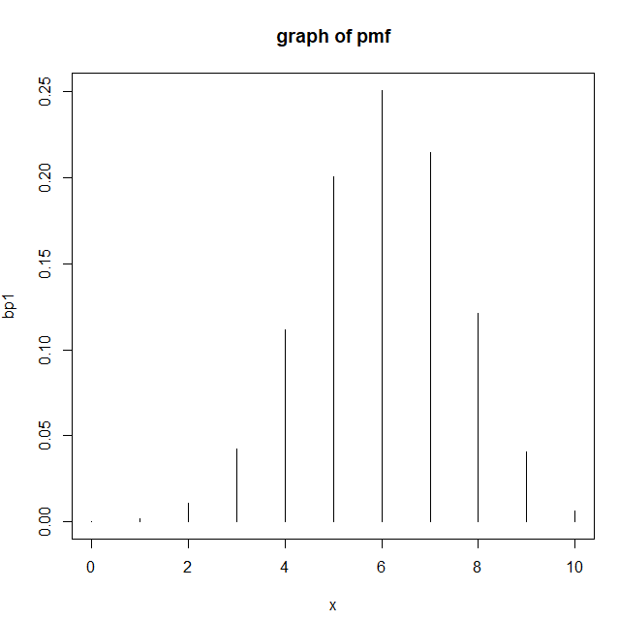
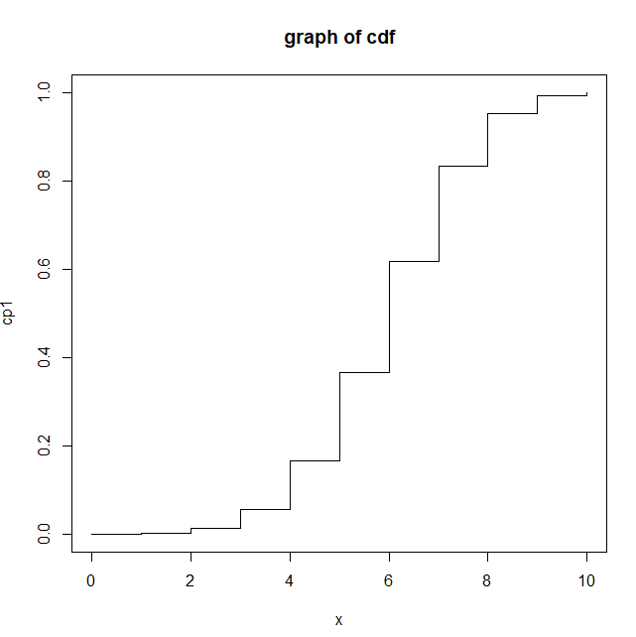

Q.7. For n=12, p=0.4, Evaluate binomial probabilities and plot the graphs of pmf and cdf.
CODE:
n=12
p=0.4
x=0:12
bp=dbinom(x,n,p)
bp
bp1=round(bp,4)
t=data.frame(x,bp1)
t
plot(x,bp1)
plot(x,bp1,"h",main="graph of pmf")
cp=pbinom(x,n,p)
cp
cp1=round(cp,4)
t=data.frame(x,cp1)
t
plot(x,cp1,"s",main="graph of cdf")
OUTPUT:
> n=12
> p=0.4
> x=0:12
> bp=dbinom(x,n,p)
> bp
[1] 2.176782e-03 1.741426e-02 6.385228e-02 1.418940e-01 2.128409e-01 2.270303e-01
[7] 1.765791e-01 1.009024e-01 4.204265e-02 1.245708e-02 2.491417e-03 3.019899e-04
[13] 1.677722e-05
> bp1=round(bp,4)
> t=data.frame(x,bp1)
> t
x bp1
1 0 0.0022
2 1 0.0174
3 2 0.0639
4 3 0.1419
5 4 0.2128
6 5 0.2270
7 6 0.1766
8 7 0.1009
9 8 0.0420
10 9 0.0125
11 10 0.0025
12 11 0.0003
13 12 0.0000
> plot(x,bp1)
> plot(x,bp1,"h",main="graph of pmf")
> cp=pbinom(x,n,p)
> cp
[1] 0.002176782 0.019591041 0.083443323 0.225337283 0.438178222 0.665208558 0.841787707
[8] 0.942690079 0.984732733 0.997189816 0.999681233 0.999983223 1.000000000
> cp1=round(cp,4)
> t=data.frame(x,cp1)
> t
x cp1
1 0 0.0022
2 1 0.0196
3 2 0.0834
4 3 0.2253
5 4 0.4382
6 5 0.6652
7 6 0.8418
8 7 0.9427
9 8 0.9847
10 9 0.9972
11 10 0.9997
12 11 1.0000
13 12 1.0000
> plot(x,cp1,"s",main="graph of cdf")

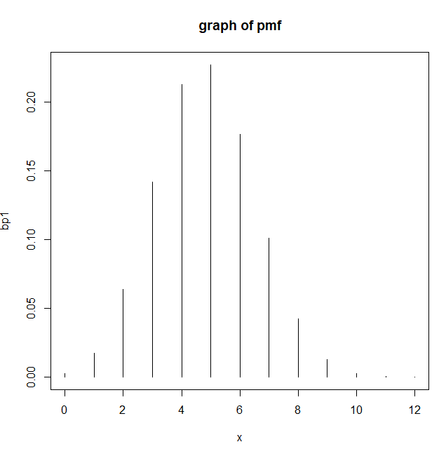
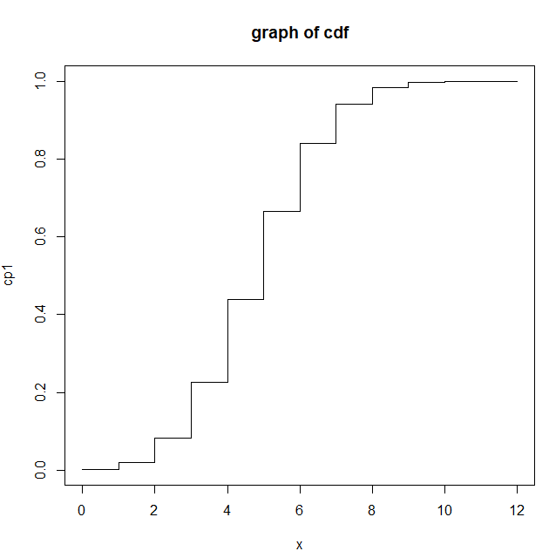
Q.8. Find x if P(X<=x)=0.8281 when n=10 and p=½
CODE:
x=qbinom(0.8281,10,1/2)
cat("The value of x if P(X<=x)=0.8281 is:",x)
OUTPUT:
> x=qbinom(0.8281,10,1/2)
> cat("The value of x if P(X<=x)=0.8281 is:",x)
The value of x if P(X<=x)=0.8281 is: 6>
Q9. Find x if P(X<=x)=0.3125 when n=4 and p=½
CODE:
x=qbinom(0.3125,4,1/2)
cat("The value of x if P(X<=x)=0.3125 is:",x)
OUTPUT:
x=qbinom(0.3125,4,1/2)
> cat("The value of x if P(X<=x)=0.3125 is:",x)
The value of x if P(X<=x)=0.3125 is: 1>
Q10. Fit the binomial distribution to the following set of data:
X: 0 1 2 3 4
f: 28 62 46 10 4
CODE:
x=c(0,1,2,3,4)
f=c(28,62,46,10,4)
n=4
m=sum(f*x)/sum(f)
m
p=m/n
bp=dbinom(x,n,p)
N=sum(f)
EF=N*bp
data.frame(x,f,bp,EF)
OUTPUT:
x=c(0,1,2,3,4)
> f=c(28,62,46,10,4)
> n=4
> m=sum(f*x)/sum(f)
> m
[1] 1.333333
> p=m/n
> bp=dbinom(x,n,p)
> N=sum(f)
> EF=N*bp
> data.frame(x,f,bp,EF)
x f bp EF
1 0 28 0.19753086 29.629630
2 1 62 0.39506173 59.259259
3 2 46 0.29629630 44.444444
4 3 10 0.09876543 14.814815
5 4 4 0.01234568 1.851852

